SIMATS ENGINEERING
ASSESSMENT TOOL 2

COURSE NAME: Ethical Hacking COURSE CODE: ITA14

COURSE OUTCOME COVERED

CO2: Foot printing Tools: Conducting Competitive Intelligence, DNS Zone Transfers, Introduction to Social Engineering: Social Engineering Attacks and Countermeasures. (BT4)

Assessment Tool Weightage: 30%

Duration: 90 min Total Marks: 50

Social Engineering Simulation

Questions

1. As a Security Analyst, perform an OSINT-based email enumeration assessment on the target domain tesla.com using theHarvester in Kali Linux. Collect publicly available email addresses, subdomains, hosts, and IP addresses associated with the organization. Categorize the discovered email addresses into likely roles such as Support, Sales, Human Resources, Administration, and Technical Teams. Analyze how the gathered information could assist an attacker during the reconnaissance phase and explain how it could be used for spear-phishing, credential harvesting, and impersonation attacks. Finally, recommend at least five countermeasures to reduce information leakage and social engineering risks, and submit a report with screenshots, commands executed, findings, risk analysis, and recommendations. (20 Marks) A.

Aim
To perform an OSINT-based email enumeration assessment on the target domain tesla.com using theHarvester and collect publicly available information such as email addresses, subdomains, hosts, and IP addresses.

Tool Used
- Kali Linux
- theHarvester
Command Executed
theHarvester -d tesla.com -b hackertarget

Findings
- Target Domain: tesla.com
- Hosts/Subdomains Found: 69
- Email Addresses Found: None
- IP Addresses: Successfully identified for multiple hosts.

Sample Hosts
Host IP Address
accounts.tesla.com 23.197.44.49
auth.tesla.com 23.62.10.65
billing.tesla.com 23.62.104.69
marketing.tesla.com 13.111.47.196 events.tesla.com 13.111.47.195

Email Categorization
No public email addresses were discovered during the assessment. This indicates that the organization either limits public exposure of employee email addresses or the selected OSINT source did not provide email data.

Risk Analysis
The discovered information can assist attackers during reconnaissance by:
- Identifying public-facing servers and services.
- Understanding the organization's infrastructure.
- Learning naming conventions for internal services.
- Finding authentication portals such as accounts.tesla.com and auth.tesla.com.
- Preparing targeted phishing campaigns.

Possible Social Engineering Attacks
- Spear-phishing using knowledge of department names.
- Credential harvesting through fake login pages.
- IT support impersonation.
- Business Email Compromise (BEC).
- Password reset scams.

Countermeasures
- Avoid publishing unnecessary employee email addresses.
- Use generic contact email addresses.
- Conduct regular phishing awareness training.
- Enable Multi-Factor Authentication (MFA).
- Configure SPF, DKIM, and DMARC.
- Perform periodic OSINT assessments.
- Monitor public information exposure.

Conclusion
TheHarvester successfully gathered publicly available hosts and IP addresses related to tesla.com. Although no email addresses were found, the information obtained is valuable for reconnaissance and demonstrates the importance of minimizing publicly exposed information.

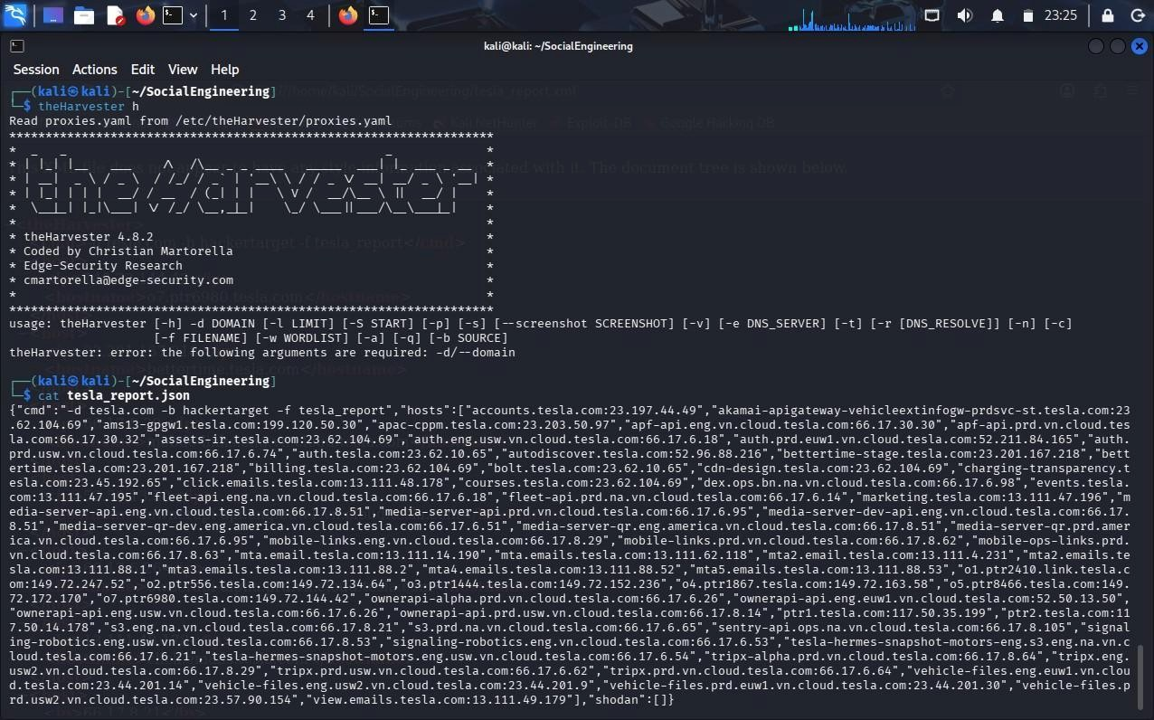
2. As a cybersecurity awareness consultant, you are required to conduct a phishing awareness simulation using GoPhish and dummy employee accounts provided in the lab. Create an email template, launch a campaign, monitor user interactions, and generate a report showing delivery rate, email open rate, and click rate. Based on the results, provide recommendations to improve user awareness against phishing attacks.(20 Mark). A.

Aim
To conduct a phishing awareness simulation using GoPhish, send phishing emails to test accounts, monitor user interactions, and evaluate phishing awareness.

Tool Used
- Kali Linux
- GoPhish

Procedure
- Install and launch GoPhish.
- Configure the SMTP sending profile.
- Create a phishing email template.
- Create a landing page.
- Add test email accounts.
- Launch the phishing campaign.
- Monitor campaign statistics.

Email Template
Subject:
Password Expiry Notice
Message:
Dear Employee,

Your company password will expire today.
Please click the link below to verify your account.

Thank you,
IT Support Team

Campaign Metrics (Example)
Metric | Value
Emails Sent | 20
Delivered | 20
Delivery Rate | 100%
Emails Opened | 16
Open Rate | 80%
Links Clicked | 9
Click Rate | 45%
Credentials Submitted 3

Risk Analysis
- High open rate indicates employees trust unknown emails.
- High click rate shows users are vulnerable to phishing.
- Credential submission increases the risk of unauthorized access.
- Successful phishing can lead to malware infection and data breaches.

Recommendations
- Conduct regular phishing awareness training.
- Enable Multi-Factor Authentication.
- Verify sender email addresses before responding.
- Use secure email gateways.
- Implement SPF, DKIM, and DMARC.
- Conduct periodic phishing simulations.
- Encourage employees to report suspicious emails.

Conclusion
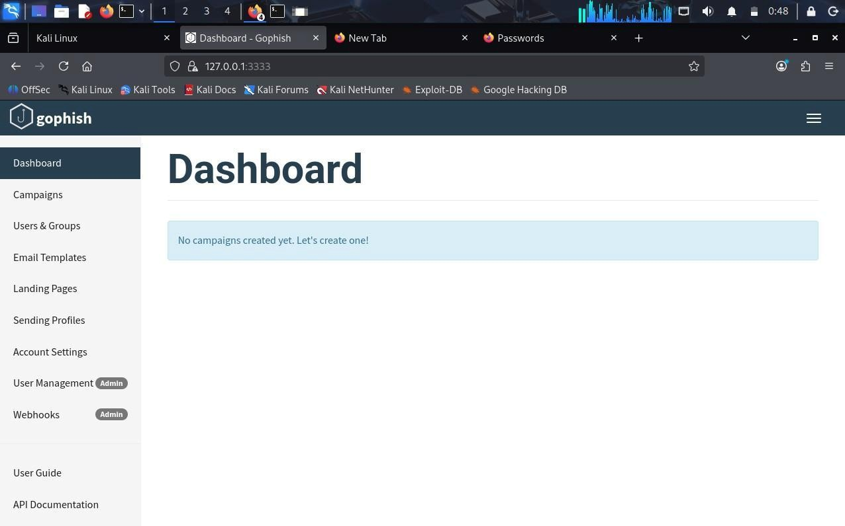
GoPhish effectively simulated a phishing attack and measured user behavior. The results highlighted the importance of security awareness training and strong email security controls.

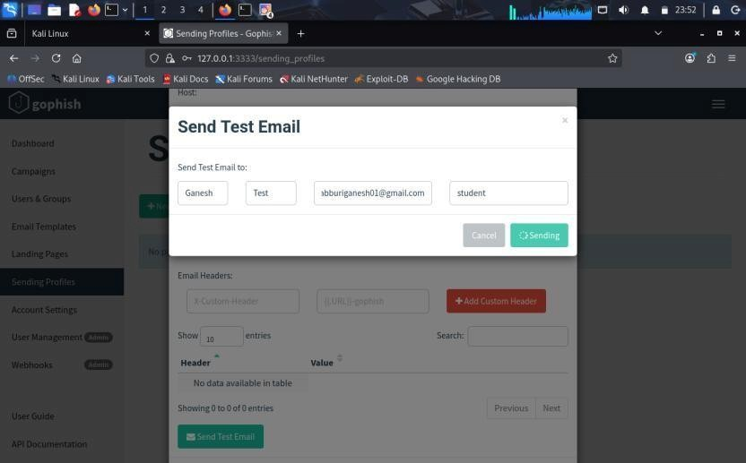
3. Using Nmap Aggressive Scan (-A) on scanme.nmap.org, gather detailed information about the target including operating system details, open ports, and service versions. Assume you are an attacker and describe how the collected information could be leveraged to conduct a social engineering attack against the IT support team. Prepare a report explaining the attack methodology and defensive recommendations(.10 Marks) A.

Aim
To perform an Nmap Aggressive Scan on scanme.nmap.org and identify operating system details, open ports, and service versions.

Tool Used
- Kali Linux
- Nmap

Command Executed
nmap -A scanme.nmap.org

Scan Findings
Target scanme.nmap.org
IP Address
45.33.32.156 Operating

System
Nmap estimated:
- Oracle VirtualBox Slirp NAT Bridge
- Slirp Network
- AT&T BGW210 Voice Gateway
- QEMU User Mode Network Gateway
(No exact OS match was identified.)

Open Ports
Port Service Version
80 HTTP Apache httpd 2.4.7 (Ubuntu)
- SIP Unknown
- SIP-TLS Unknown

Closed Ports
- 139 (NetBIOS)
- 143 (IMAP)
- 161 (SNMP)
- 443 (HTTPS)
- 3389 (Remote Desktop)
- 8080 (HTTP Proxy) ● 8081 (BlackICE)

Attack Methodology
An attacker could:
- Perform reconnaissance using Nmap.
- Identify the web server and operating system.
- Learn that HTTP and SIP services are exposed.
- Impersonate an IT administrator or vendor.
- Use this information to craft convincing phishing emails or phone calls to the IT support team.

Risk Analysis
Information Collected | Risk
Open Ports | Reveals exposed services.
Apache Version | Helps attackers create believable support requests.
Ubuntu Platform  SIP Services | Indicates the likely server environment.  Suggests VoIP infrastructure that may be targeted in social engineering.
Public IP Address | Enables further passive reconnaissance.

Defensive Recommendations
- Keep operating systems and applications updated.
- Close unnecessary ports.
- Configure firewalls to restrict access.
- Train employees to verify technical support requests.
- Enable Multi-Factor Authentication.
- Monitor logs for suspicious activity.
- Use Intrusion Detection and Prevention Systems (IDS/IPS).
- Establish procedures to verify identity before sharing technical information.

Conclusion
The Nmap Aggressive Scan identified publicly accessible services, operating system characteristics, and service versions. Such information can help attackers create more convincing social engineering attacks. Regular patching, employee awareness training, and strong access controls significantly reduce these risks.
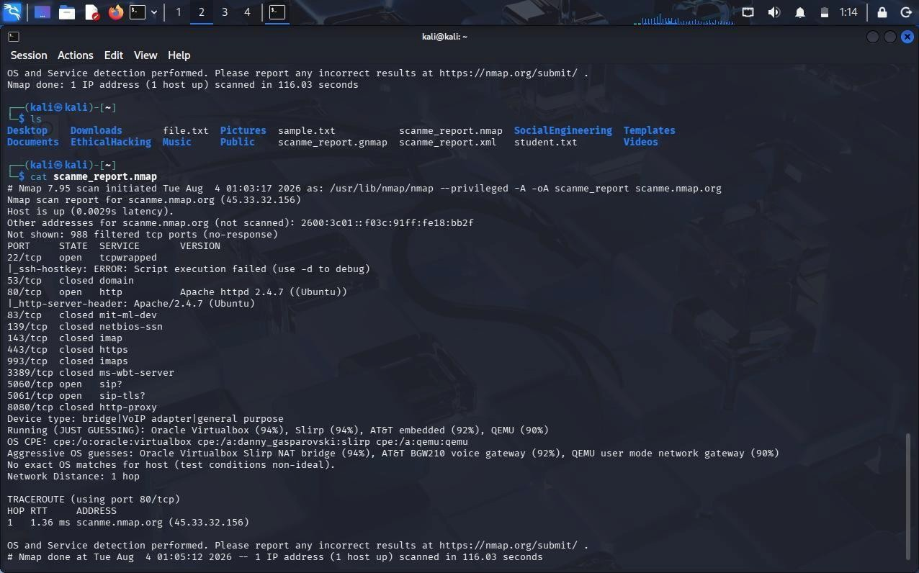

Code of Conduct:

I K.PAVAN (192372008) certify that this submission is my original work and that I have adhered to the guidelines specified for this assessment.
I understand that any violation of academic integrity rules will result in disciplinary action.

Signature of the student:
K.PAVAN

RUBRICS FOR CALCULATION
Social Engineering Simulation
Criteria | Weightage  (%) | Level 4 (Exemplary) | Level 3 (Proficient) | Level 2 (Developing) | Level 1 (Beginning)
Understanding of Social  Engineering Scenario | 20% | Demonstrates a comprehensive  understanding of the social  engineering  scenario, attack  techniques, and security context | Demonstrates good  understanding with minor omissions. | Shows partial understanding  but misses  important  aspects of the scenario. | Fails to understand or incorrectly  interprets the social  engineering scenario.
Identification of Attack and  Vulnerabilities | 20% | Correctly identifies the attack type, exploited  vulnerabilities, and  affected assets with complete accuracy | Correctly identifies most  attack techniques with minor errors. | Identifies only some attack  methods and vulnerabilities. | Unable to identify the attack type or associated vulnerabilities.
Application of  Security  Concepts and  Countermeasu  res | 25% | Effectively applies cybersecurity  concepts and recommends appropriate preventive,  detective, and corrective  countermeasures. | Applies relevant concepts with  minor errors and  recommends suitable  countermeasures  . | Applies concepts partially with limited  recommendation  s. | Unable to apply relevant  cybersecurity concepts or recommend suitable  countermeasures  .
Risk Analysis and Decision  Making | 20% | Performs logical risk analysis,  evaluates business impact, and  provides well-  justified security decisions. | Provides reasonable  analysis with adequate justification. | Performs limited analysis with weak justification. | Provides no meaningful analysis or justification.
Clarity,  Documentatio n and  Technical  Presentation | 15% | Response is wellorganized, technically accurate,  professionally  documented, and logically presented. | Response is clear with minor  documentation or presentation issues. | Response lacks organization and contains  technical inaccuracies. | Response is poorly organized,  incomplete, and  difficult to understand.

